Project Phase 3

Kernel Panic
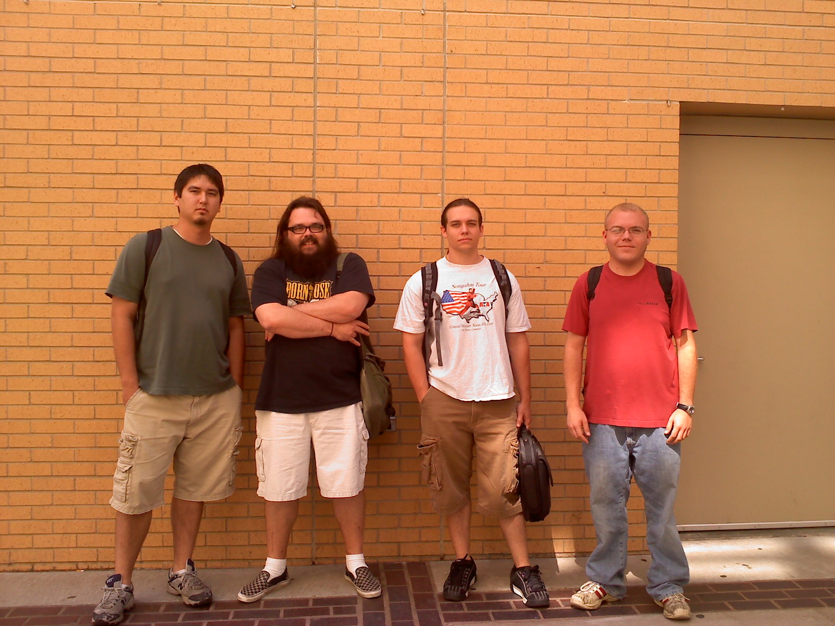
Christopher Greinke, Doug VanAllen, James Butts, Johnathan Pelz

Table of Contents

1 Class Diagrams
  - Overall Class Diagram
  - Entity Class Diagram
  - Control Class Diagram
  - Boundary Class Diagram

2 Tabular Representation
  - Entity Classes
  - Control Classes
  - Boundary Classes

1 Class Diagrams

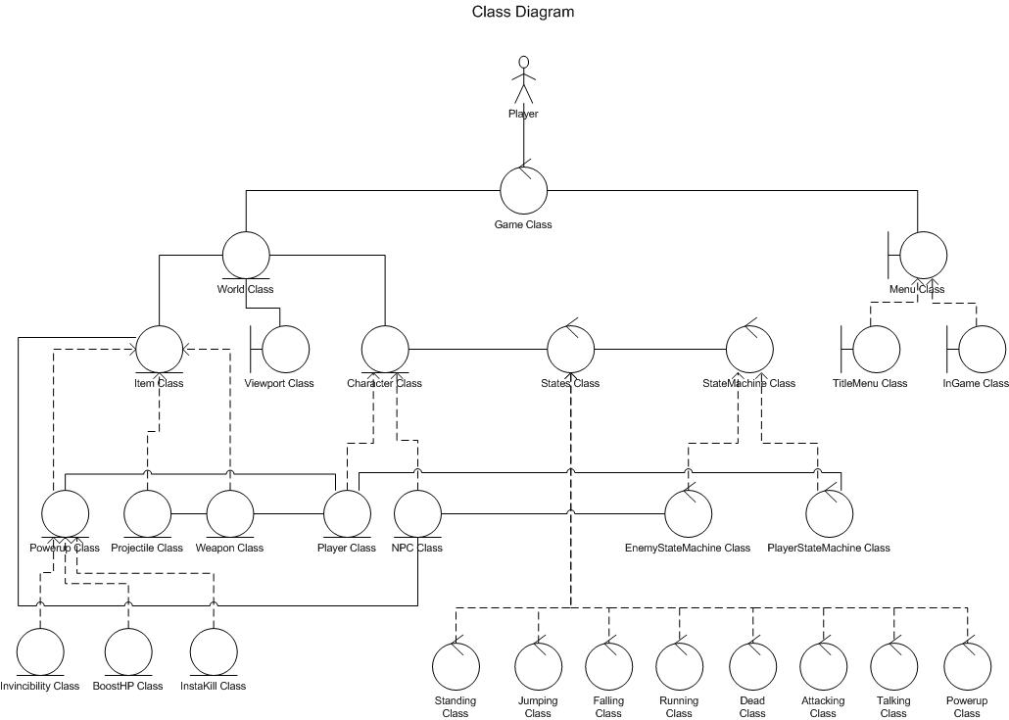
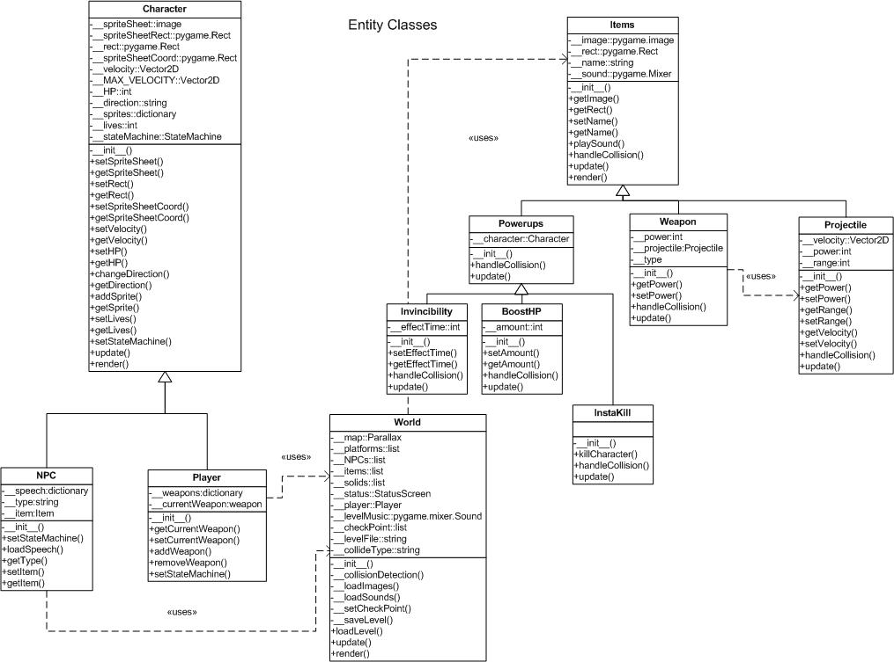

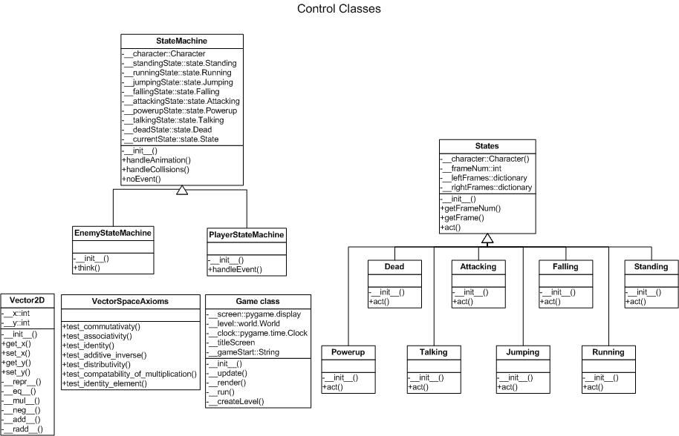

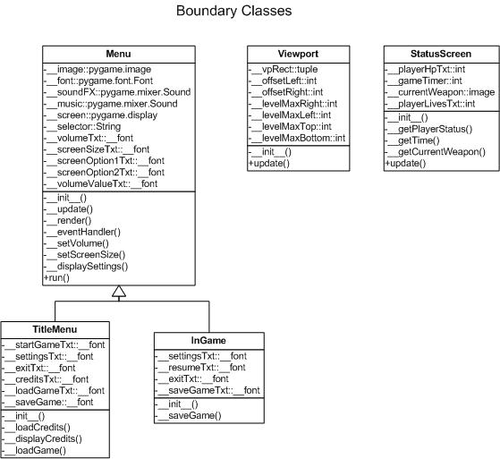

2 Tabular Representation of the Class Diagram

2.1 Entity Classes
    - Item Class
    - Weapon Class
    - Projectile Class
    - PowerUp Class
    - Invincibility Class
    - BoostHP Class
    - InstaKill Class
    - Character Class
    - Player Class
    - NPC Class
    - World Class

Item Class
Module name __init___
Module type Function
Return type none
Input arguments image::pygame.image
rect::pygame.Rect
name::string
sound::pygame.mixer
Output arguments none
Error messages none
Files accessed none
Files changed none
Modules called none
Narrative Assign image, rect, name, and sound argument variables to _image, _rect, _name, and _sound class variables respectively.

Module name getImage
Module type Function
Return type pygame.image
Input arguments none
Output arguments _image::pygame.image
Error messages none
Files accessed none
Files changed none
Modules called none
Narrative Returns the appropriate image stored in the class variable _image.

Module name getRect
Module type Function
Return type pygame.Rect
Input arguments none
Output arguments _rect::pygame.Rect
Error messages none
Files accessed none
Files changed none
Modules called none
Narrative Returns the appropriate rect stored in the class variable _rect.

Module name setName
Module type Function
Return type none
Input arguments name::string
Output arguments none
Error messages none
Files accessed none
Files changed none
Modules called none
Narrative Set the class variable _name equal to the argument value name.

Module name getName
Module type Function
Return type string
Input arguments none
Output arguments _name::string
Error messages none
Files accessed none
Files changed none
Modules called none
Narrative Returns the appropriate name stored in the class variable _name.

Module name playSound
Module type Function
Return type none
Input arguments none
Output arguments none
Error messages none
Files accessed _sound
Files changed none
Modules called none
Narrative Play the appropriate sound located in the class variable _sound by calling self._sound.play().

Module name update
Module type Function
Return type none
Input arguments none
Output arguments none
Error messages none
Files accessed none
Files changed none
Modules called none
Narrative An virtual function who's only purpose is to dynamically bind it's derived classes update functions.

Module name render
Module type Function
Return type none
Input arguments screen::pygame.display
Output arguments none
Error messages none
Files accessed none
Files changed none
Modules called none
Narrative Render will blit the _image in the _rect position.

Weapons Class
Module name __init___
Module type Function
Return type none
Input arguments image::pygame.image
rect::pygame.Rect
name::string
sound::pygame.mixer
power::int
projectile::Projectile
Output arguments none
Error messages none
Files accessed none
Files changed none
Modules called Item.__init__()
Narrative Call the base classes’ constructor and pass in image, rect, name, and sound. Assign power and projectile argument variables to _power and projectile class variables respectively.

Module name getPower
Module type Function
Return type int
Input arguments none
Output arguments _power::int
Error messages none
Files accessed none
Files changed none
Modules called none
Narrative Returns the class variable _power.

Module name setPower
Module type Function
Return type none
Input arguments power::int
Output arguments none
Error messages none
Files accessed none
Files changed none
Modules called none
Narrative Set the class variable _power equal to the argument value power.

Module name getProjectile
Module type Function
Return type Projectile
Input arguments none
Output arguments _projectile::Projectile
Error messages none
Files accessed none
Files changed none
Modules called none
Narrative Returns the class variable _power.

Module name setProjectile
Module type Function
Return type none
Input arguments projectile::Projectile
Output arguments none
Error messages none
Files accessed none
Files changed none
Modules called none
Narrative Set the class variable _projectile equal to the argument value projectile.

Projectile Class
Module name __init___
Module type Function
Return type none
Input arguments image::pygame.image
rect::pygame.Rect
name::string
sound::pygame.mixer
velocity::Vector2D
power::int
range::int
Output arguments none
Error messages none
Files accessed none
Files changed none
Modules called Item.__init__()
Narrative Call the base classes’ constructor and pass in image, rect, name, and sound. Assign velocity, power, and range argument variables to _velocity, _power, and _range class variables respectively.

Module name getPower
Module type Function
Return type none
Input arguments none
Output arguments _power::int
Error messages none
Files accessed none
Files changed none
Modules called none
Narrative Returns the class variable _power.

Module name setPower
Module type Function
Return type none
Input arguments power::int
Output arguments none
Error messages none
Files accessed none
Files changed none
Modules called none
Narrative Set the class variable _power equal to the argument value power.

Module name getRange
Module type Function
Return type int
Input arguments none
Output arguments _range::int
Error messages none
Files accessed none
Files changed none
Modules called none
Narrative Returns the class variable _range.

Module name setRange
Module type Function
Return type none
Input arguments range::int
Output arguments none
Error messages none
Files accessed none
Files changed none
Modules called none
Narrative Set the class variable _range equal to the argument value range.

Module name getVelocity
Module type Function
Return type Vector2D
Input arguments none
Output arguments _velocity::Vector2D
Error messages none
Files accessed none
Files changed none
Modules called none
Narrative Returns the class variable _velocity.

Module name setVelocity
Module type Function
Return type none
Input arguments velocity::Vector2D
Output arguments none
Error messages none
Files accessed none
Files changed none
Modules called none
Narrative Set the class variable _velocity equal to the argument value velocity.

Module name update
Module type Function
Return type none
Input arguments none
Output arguments none
Error messages none
Files accessed none
Files changed none
Modules called none
Narrative Offset the Projectile Item's _rect by the current _velocity's x and y values by calling move().

PowerUp Class
Module name __init___
Module type Function
Return type none
Input arguments image::pygame.image
rect::pygame.Rect
name::string
sound::pygame.mixer
character::Character
Output arguments none
Error messages none
Files accessed none
Files changed none
Modules called Item.__init__()
Narrative Call the base classes’ constructor and pass in image, rect, name, and sound. Assign character argument variable to _character class variable.

Invisibility Class
Module name __init___
Module type Function
Return type none
Input arguments image::pygame.image
rect::pygame.Rect
name::string
sound::pygame.mixer
effectTime::int
Output arguments none
Error messages none
Files accessed none
Files changed none
Modules called Item.__init__()
Narrative Call the base classes’ constructor and pass in image, rect, name, and sound. Assign character argument variable to _effectTime class variable.

Module name getEffectTime
Module type Function
Return type int
Input arguments none
Output arguments _effectTime
Error messages none
Files accessed none
Files changed none
Modules called none
Narrative Returns the class variable _effectTime.

Module name setEffectTime
Module type Function
Return type none
Input arguments effectTime::int
Output arguments none
Error messages none
Files accessed none
Files changed none
Modules called none
Narrative Set the class variable _effectTime equal to the argument value effectTime.

BoostHP Class
Module name __init___
Module type Function
Return type none
Input arguments image::pygame.image
rect::pygame.Rect
name::string
sound::pygame.mixer
amount::int
Output arguments none
Error messages none
Files accessed none
Files changed none
Modules called Item.__init__()
Narrative Call the base classes’ constructor and pass in image, rect, name, and sound. Assign amount argument variable to _amount class variable.

Module name setAmount
Module type Function
Return type none
Input arguments amount::int
Output arguments none
Error messages none
Files accessed none
Files changed none
Modules called none
Narrative Set the class variable _amount equal to the argument value amount.

Module name getAmount
Module type Function
Return type int
Input arguments none
Output arguments _amount::int
Error messages none
Files accessed none
Files changed none
Modules called none
Narrative Returns the class variable _amount.

InstaKill Class
Module name __init___
Module type Function
Return type none
Input arguments image::pygame.image
rect::pygame.Rect
name::string
sound::pygame.mixer
amount::int
Output arguments none
Error messages none
Files accessed none
Files changed none
Modules called Item.__init__()
Narrative Call the base classes’ constructor and pass in image, rect, name, and sound. Assign amount argument variable to _amount class variable.

Module name killCharacter
Module type Function
Return type none
Input arguments none
Output arguments none
Error messages none
Files accessed none
Files changed none
Modules called none
Narrative Subtract _amount of HP from the character's HP value.

Character Class
Module name __init___
Module type Function
Return type none
Input arguments spriteSheet::Image
sprites::dictionary
MAX_VELOCITY::Vector2D
stateMachine::stateMachine
Output arguments none
Error messages none
Files accessed spriteSheet::Image
Files changed none
Modules called none
Narrative Assign spriteSheet, sprites, MAX_VELOCITY, and stateMachine argument variables to _spriteSheet, _sprites, _MAX_VELOCITY, and _stateMachine class variables respectively.

Module name setSpriteSheet
Module type Function
Return type none
Input arguments spriteSheet::image
Files accessed none
Files changed none
Modules called none
Narrative Set the class variable _spriteSheet equal to the argument value spriteSheet.

Module name getSpriteSheet
Module type Function
Return type Image
Input arguments none
Files accessed none
Files changed none
Modules called none
Narrative Returns the class variable _spriteSheet.

Module name setRect
Module type Function
Return type none
Input arguments levelPostion::pygame.Rect
Files accessed none
Files changed none
Modules called none
Narrative Set the class variable _levelPosition equal to the argument value levelPosition.

Module name getRect
Module type Function
Return type pygame.Rect
Input arguments none
Files accessed none
Files changed none
Modules called none
Narrative Returns the class variable _rect.

Module name setSpriteSheetCoord
Module type Function
Return type none
Input arguments rect::pygame.Rect
Files accessed none
Files changed none
Modules called none
Narrative Set the class variable _spriteSheetCoord equal to the argument value rect.

Module name getSpriteSheetCoord
Module type Function
Return type pygame.Rect
Input arguments none
Files accessed none
Files changed none
Modules called none
Narrative Returns the class variable _spriteSheetCoord.

Module name setVelocity
Module type Function
Return type none
Input arguments velocity::Vector2D
Files accessed none
Files changed none
Modules called none
Narrative Set the class variable _velocity equal to the argument value velocity.

Module name getVelocity
Module type Function
Return type Vector2D
Input arguments none
Files accessed none
Files changed none
Modules called none
Narrative Returns the class variable _velocity.

Module name setHP
Module type Function
Return type none
Input arguments life::int
Files accessed none
Files changed none
Modules called none
Narrative Set the class variable _life equal to the argument value life.

Module name getHP
Module type Function
Return type Int
Input arguments none
Files accessed none
Files changed none
Modules called none
Narrative Returns the class variable __HP.

Module name changeDirection
Module type Function
Return type none
Input arguments direction::String
Files accessed none
Files changed none
Modules called none
Narrative Set the class variable _direction equal to the argument value direction.

Module name getDirection
Module type Function
Return type String
Input arguments none
Files accessed none
Files changed none
Modules called none
Narrative Returns the class variable _direction.

Module name addSprite
Module type Function
Return type none
Input arguments key::String
rect::pygame.Rect
Files accessed none
Files changed none
Modules called none
Narrative Append a new key-value pair to the _sprites list using the key and rect argument variables respectively.

Module name getSprite
Module type Function
Return type pygame.Rect
Input arguments key::String
Files accessed none
Files changed none
Modules called none
Narrative Returns a rect by indexing the _sprites dictionary with the key argument.

Module name setLives
Module type Function
Return type none
Input arguments numLives::int
Files accessed none
Files changed none
Modules called none
Narrative Set the class variable _lives equal to the argument value numLives.

Module name getLives
Module type Function
Return type int
Input arguments none
Files accessed none
Files changed none
Modules called none
Narrative Returns the class variable _lives.

Module name setStateMachine
Module type Function
Return type none
Input arguments stateMachine::StateMachine
Files accessed none
Files changed none
Modules called none
Narrative Set the class variable _stateMachine equal to the argument value stateMachine.

Module name update
Module type Abstract Method
Return type none
Input arguments none
Files accessed none
Files changed none
Modules called none
Narrative An virtual function who's only purpose is to dynamically bind it's derived classes update functions.

Player Class
Module name __init___
Module type Function
Return type none
Input arguments none
Output arguments none
Error messages none
Files accessed none
Files changed none
Modules called Character.__init__()
Narrative Call the base classes’ constructor and pass in default values for spriteSheet, sprites, MAX_VELOCITY, stateMachine.

Module name getCurrentWeapon
Module type Function
Return type Weapon
Input arguments none
Output arguments returns _currentWeapon.
Error messages none
Files accessed none
Files changed none
Modules called none
Narrative Returns the class variable _currentWeapon.

Module name setCurrentWeapon
Module type Function
Return type none
Input arguments keyString::String
Output arguments none
Error messages none
Files accessed none
Files changed none
Modules called none
Narrative Set class variable _currentWeapon to the value corresponding to keyString in the _weapons dictionary.

Module name addWeapon
Module type Function
Return type none
Input arguments weapon::Weapon
keyString::String
Output arguments none
Error messages none
Files accessed none
Files changed none
Modules called none
Narrative Append a new key-value pair to the _weapons dictionary using the keyString and weapon argument variables respectively.

Module name removeWeapon
Module type Function
Return type none
Input arguments keyString::String
Output arguments none
Error messages none
Files accessed none
Files changed none
Modules called none
Narrative Delete a weapon from the _weapons dictionary that that is retrieved by indexing with the keyString argument variable.

Module name setStateMachine
Module type Function
Return type none
Input arguments stateMachine::StateMachine
Output arguments none
Error messages none
Files accessed none
Files changed none
Modules called none
Narrative Set the class variable _stateMachine equal to the argument variable stateMachine.

NPC Class
Module name __init__
Module type Function
Return type none
Input arguments type::String
speechFile::String
Item::Item
Output arguments none
Error messages none
Files accessed none
Files changed none
Modules called Character.__init__(), loadSpeech()
Narrative Call base class constructor. Set class variables _type and _item to type and item argument variables respectively. Call loadSpeech(speechFile).

Module name setStateMachine
Module type Function
Return type none
Input arguments stateMachine::StateMachine
Output arguments none
Error messages none
Files accessed none
Files changed none
Modules called none
Narrative Set the class variable _stateMachine equal to the argument value stateMachine.

Module name loadSpeech
Module type Function
Return type none
Input arguments speechFile::String
Output arguments none
Error messages If file fails to load, throw an exception.
Files accessed #spechFile#.txt
Files changed none
Modules called open()
Narrative Load textual information from given argument file name.

Module name getType
Module type Function
Return type String
Input arguments none
Output arguments none
Error messages none
Files accessed none
Files changed none
Modules called none
Narrative Returns the class variable _type.

Module name setItem
Module type Function
Return type none
Input arguments item::Item
Output arguments none
Error messages none
Files accessed none
Files changed none
Modules called none
Narrative Set the class variable _item equal to the argument value item.

Module name getItem
Module type Function
Return type Item
Input arguments none
Output arguments none
Error messages none
Files accessed none
Files changed none
Modules called none
Narrative Returns the class variable _item.

World Class
Module name __init__
Module type Function
Return type none
Input arguments levelFile
Output arguments none
Error messages none
Files accessed checkpoint.ckp, level.lvl, level.ogg,
Files changed checkPoint.ckp, level.lvl
Modules called pygame.mixer.sound(), pygame.image.load(),
image.get_rect(), loadLevel()
Narrative This module initializes the world class. Sets all class variables to null. Call loadLevel based upon the argument from __init__().

Module name _loadLevel
Module type Function
Return type none
Input argument levelFile::String
Output arguments none
Error messages Cannot access file.
Files accessed levelFile
Files changed none
Modules called none
Narrative Loads the file based on the argument levelFile. Appropriately sets all the World class variables to the values denoted by contents of levelFile.

Module name update
Module type Function
Return type none
Input arguments none
Output arguments none
Error messages none
Files accessed none
Files changed none
Modules called collisionDetection()
Narrative Call collisionDetection() to update all objects in the World.

Module name render
Module type Function
Return type none
Input arguments none
Output arguments none
Error messages none
Files accessed none
Files changed none
Modules called pygame.flip(), pygame.blit(), render()
Narrative Calls render() for all objects in the World. Calls pygame.flip() and pygame.blit().

Module name _saveLevel
Module type Function
Return type none
Input arguments none
Output arguments none
Error messages none
Files accessed checkpoint.ckp
Files changed checkpoint.ckp
Modules called open(), close()
Narrative Take current object variable values and write to checkpoint.ckp in a specified delimited format.

Module name _collisionDetection
Module type Function
Return type none
Input arguments none
Output arguments none
Error messages none
Files accessed none
Files changed none
Modules called StateMachine.handleCollision(), pygame.colliderect()
Narrative Check intersections of rectangles between characters, World objects, and projectiles by calling pygame.colliderect(). Calls the StateMachines handleCollision() on the character.

Module name _loadImage
Module type Function
Return type none
Input arguments fileName::String
Output arguments none
Error messages none
Files accessed Appropriate image file (png, jpg, or ).
Files changed none
Modules called pygame.image.load()
Narrative Load an image with a name equal to argument variable filename.

Module name _loadSound
Module type Function
Return type none
Input arguments fileName::String
Output arguments none
Error messages none
Files accessed Appropriate sound file (ogg).
Files changed none
Modules called pygame.mixer.Sound()
Narrative Load a sound with a name equal to argument variable filename.

Module name _reachedCheckPoint
Module type Function
Return type none
Input arguments characterRect::rect
Output arguments none
Error messages none
Files accessed none
Files changed none
Modules called _saveLevel()
Narrative Checkes characterRect against class variable _checkPoint to determine if the characters position has either reached or passed _checkPoint .

2.2 Control Classes
  - Game Class
  - StateMachine Class
  - EnemyStateMachine Class
  - PlayerStateMachine Class
  - State Class
  - Standing Class
  - Standing Class
  - Jumping Class
  - Falling Class
  - Running Class
  - Dead Class
  - Attacking Class
  - Talking Class
  - PowerUp Class

Game Class
Module name __init__
Module type Function
Return type none
Input arguments none
Output arguments none
Error messages none
Files accessed none
Files changed none
Modules called none
Narrative Sets class variables to their initial values.
_screen to 640x480, _level to level one, _clock to pygame.time.Clock(), _titleScreen to current, _gameStart to false.

Module name update
Module type Function
Return type none
Input arguments updateFlag::String
Output arguments none
Error messages none
Files accessed none
Files changed none
Modules called _titleScreen.update(), _level.update()
Narrative Based on the updateFlag call either _titleScreen.update(), or _level.update().

Module name render
Module type Function
Return type none
Input arguments updateFlag::String
Output arguments none
Error messages none
Files accessed none
Files changed none
Modules called _titleScreen.render(), _level.render()
Narrative Based on the updateFlag call either _titleScreen.render(), or _level.render().

Module name run
Module type Function
Return type none
Input arguments none
Output arguments none
Error messages none
Files accessed none
Files changed none
Modules called update(), render()
Narrative This is the main game loop. Pass a string as an argument to tell update and render what to update or render.

StateMachine Class

Module name __init___
Module type Function
Return type none
Input arguments character::character, sprite::dictionary
Output arguments none
Error messages none
Files accessed none
Files changed none
Modules called none
Narrative Sets class variables _character and _sprites to the passed in arguments character and sprite. Create instances of all the states and assign the states to class variables. Set the class variable _isJumping to false. Add the falling state to the class dictionary_currentStates.

Module name handleAnimation
Module type Function
Return type none
Input arguments none
Output arguments none
Error messages none
Files accessed none
Files changed none
Modules called self._character.setSpriteSheetCoord()
Narrative Checks character’s dictionary of sprites and cycles through the dictionary with each call. There is a priority to which sprites to display. Attacking, running, then standing respectively. If switching from a new state's sprites then reset the frame number of the previous state.

Module name translate
Module type Function
Return type String
Input arguments rect::pygame.Rect()
Output argument typeOfColl
Error messages none
Files accessed none
Files changed none
Modules called self._character.getRect()
Narrative This method will calculate the minimum translation distance. This distance is the smallest of the distances between:
The character's bottom with the rect's top,
The character's top with the rect's bottom,
The character's left with the rect's right,
The character's right with the rect's left.
Takes the shortest distance of these and translates the character's position accordingly, based on the collision. Also set the character's X or Y Velocity to zero, based upon the collision.

Module name act
Module type Function
Return type none
Input argument none
Output arguments none
Error messages none
Files accessed none
Files changed none
Modules called self._currentStates.has_key(), state.act()
Narrative For each state in the current state dictionary call the state's act(). Then check to see if the current state dictionary contains the jumping state, if so then remove from the dictionary.

Module name kill
Module type Function
Return type none
Input argument none
Output arguments none
Error messages none
Files accessed none
Files changed none
Modules called self._currentStates.has_key()
Narrative Check to see if the running state are in the state's dictionary, if so then remove from the dictionary. Then add the dead state to the dictionary.

Module name move
Module type Function
Return type none
Input argument none
Output arguments none
Error messages none
Files accessed none
Files changed none
Module called self._character.getRect()
Narrative Move the character's position based upon the character's velocity.

EnemyStateMachine Class
Module name __init__
Module type Function
Return type none
Input arguments character::character, sprites::dictionary, playerRect::pygame.Rect, topographyRects::pygame.Rect
Output arguments none
Error messages none
Files accessed none
Files changed none
Modules called self.tRects.append(), super().__init__()
Narrative Calls base class's __init__(), passing character and sprites as paramaters. Add the running state and falling state to the _currentStates's dictionary. Set class variable counter to zero. For every rectangle in topographyRects append it to the class variable tRects.

Module name think
Module type Function
Return type none
Input arguments none
Output arguments none
Error messages none
Files accessed none
Files changed none
Modules called _currentStates[state].act(), _currentStates.has_key(), self._character.getRect().collideRect(), handleCollision()
Narrative For every state in currentStates call the state's act(). Then if jumping state is in the currentState then delete it. Call handleCollision for every rect in tRect. In short based on the character’s type, currentState, and level topography change currentState to a different state.

Module name turnAround
Module type Function
Return type none
Input arguments none
Output arguments none
Error messages none
Files accessed none
Files changed none
Modules called _character.getDirection(), _character.setDirection(), _currentState.has_key()
Narrative Based upon the character's direction, change the direction to the opposite direction. Set the character's X Velocity to zero.

Module name handleCollision
Module type Function
Return type none
Input arguments type::String, rect::pygame.Rect
Output arguments none
Error messages none
Files accessed none
Files changed none
Modules called translate(), turnAround()
Narrative Based on the type of collision, which is passed as the input argument type, either turn around if collides with solid, or decrements the HP if collides with enemy.

PlayerStateMachine Class
Module name __init__
Module type Function
Return type none
Input arguments character::character, sprites::Dictionary
Output arguments none
Error messages none
Files accessed none
Files changed none
Modules called super().__init__()
Narrative Call the parent class’s constructors, passing both input parameters.

Module name handleEvent ()
Module type Function
Return type none
Input arguments events::list
Output arguments none
Error messages none
Files accessed none
Files changed none
Modules called sys.exit(), _currentState.has_key(), _character.setDirection(), _character.getDirection(), act()
Narrative Add states to the currentStates, based upon the key down events. Remove states based upon key up events. Based on event set the currentStates and remove states. Then call act().

Module name pushEnemy
Module type Function
Return type none
Input arguments enemy::pygame.Rect, direction::String
Output arguments none
Error messages none
Files accessed none
Files changed none
Modules called none
Narrative Based on the direction the player pushes the enemy, translate the enemy position by 150 pixels.

Module name handleCollision
Module type Function
Return type String
Input arguments type::String, rect::pygame.Rect
Output arguments coll
Error messages none
Files accessed none
Files changed none
Modules called translate()
Narrative Based upon the input argument type, call translate to adjust the character's position.
State Class
Module name __init__
Module type Function
Return type none
Input arguments character::character, rightFrames::dictionary, leftFrames::dictionary
Output arguments none
Error messages none
Files accessed none
Files changed none
Modules called none
Narrative Set all class variables to their corresponding init arguments. With the exception of frame number which gets set to zero.

Module name getFrame()
Module type Function
Return type Integer
Input arguments frameSet::String
Output arguments String that represents Sprite.
Error messages none
Files accessed none
Files changed none
Modules called none
Narrative Return the string that corresponds to a key in the character's sprite
dictionary to retrieve a frame for animation. _frameNum is used to
cycle through the appropriate frame set for animation. The frameSet is
a collection of strings which will be used as keys in the sprite
dictionary.

Module name getFrameNum()
Module type Function
Return type Integer
Input arguments none
Output arguments _frameNum::int
Error messages none
Files accessed none
Files changed none
Modules called none
Narrative Returns the current frame.

Module name setFrameNum()
Module type Function
Return type none
Input arguments num::int
Output arguments none
Error messages none
Files accessed none
Files changed none
Modules called none
Narrative Sets the current frame number to input argument.

Module name resetFrames
Module type Function
Return type none
Input arguments none
Output arguments none
Error messages none
Files accessed none
Files changed none
Modules called none
Narrative Sets the _frameNum to zero.

Module name act()
Module type Function
Return type none
Input arguments none
Output arguments none
Error messages none
Files accessed none
Files changed none
Modules called none
Narrative This method is a pure virtual method to be overridden by derived classes. Each state has it's own act method which will be called to perform some action on the character.

Standing Class
Module name __init__
Module type Function
Return type none
Input arguments character::character, rightFrames::Dictionary, leftFrames::Dictionary
Output arguments none
Error messages none
Files accessed none
Files changed none
Modules called super().__init__()
Narrative Call the parent class’s constructors.

Module name act()
Module type Function
Return type none
Input arguments none
Output arguments none
Error messages none
Files accessed none
Files changed none
Modules called none
Narrative Will set the x and y velocity values to zero.

Jumping Class
Module name __init__
Module type Function
Return type none
Input arguments character::character, rightFrames::Dictionary, leftFrames::Dictionary
Output arguments none
Error messages none
Files accessed none
Files changed none
Modules called super().__init__()
Narrative Call the parent class’s constructors.

Module name act()
Module type Function
Return type none
Input arguments none
Output arguments none
Error messages none
Files accessed none
Files changed none
Modules called none
Narrative Set the Y Velocity to the negative MAX_VELOCITY.

Falling Class
Module name __init__
Module type Function
Return type none
Input arguments character::character, rightFrames::Dictionary, leftFrames::Dictionary
Output arguments none
Error messages none
Files accessed none
Files changed none
Modules called super().__init__()
Narrative Call the parent class’s constructors.

Module name act()
Module type Function
Return type none
Input arguments none
Output arguments none
Error messages none
Files accessed none
Files changed none
Modules called none
Narrative Increment y velocity with each call until velocity is equal to MAX_VELOCITY. If the velocity equals MAX_VELOCITY, no calculations need to be performed so do nothing.

Running Class
Module name __init__
Module type Function
Return type none
Input arguments character::character, rightFrames::Dictionary, leftFrames::Dictionary
Output arguments none
Error messages none
Files accessed none
Files changed none
Modules called super().__init__()
Narrative Call the parent class’s constructors.

Module name act()
Module type Function
Return type none
Input arguments none
Output arguments none
Error messages none
Files accessed none
Files changed none
Modules called none
Narrative Based on the character's direction either increment or decrements the x velocity until it reaches MAX_VELOCITY.

Dead Class
Module name __init__
Module type Function
Return type none
Input arguments character::character, rightFrames::Dictionary, leftFrames::Dictionary
Output arguments none
Error messages none
Files accessed none
Files changed none
Modules called super().__init__()
Narrative Call the parent class’s constructors.

Module name act()
Module type Function
Return type none
Input arguments none
Output arguments none
Error messages none
Files accessed none
Files changed none
Modules called none
Narrative Take away a character life. Set x and y velocity to zero.

Attacking Class
Module name __init__
Module type Function
Return type none
Input arguments character::character, rightFrames::Dictionary, leftFrames::Dictionary
Output arguments none
Error messages none
Files accessed none
Files changed none
Modules called super().__init__()
Narrative Call the parent class’s constructors.

Module name act()
Module type Function
Return type none
Input arguments none
Output arguments none
Error messages none
Files accessed none
Files changed none
Modules called character.getCurrentWeapon(), Projectile()
Narrative Inject projectile into the world, based upon the current weapon type.

Talking Class
Module name __init__
Module type Function
Return type none
Input arguments character::character, rightFrames::Dictionary, leftFrames::Dictionary
Output arguments none
Error messages none
Files accessed none
Files changed none
Modules called super().__init__()
Narrative Call the parent class’s constructors.

Module name act()
Module type Function
Return type none
Input arguments none
Output arguments none
Error messages none
Files accessed dialogFile.txt
Files changed none
Modules called none
Narrative Will set the x and y velocity values to zero. Initiate dialog with string from dialogFile.txt.

PowerUp Class
Module name __init__
Module type Function
Return type none
Input arguments character::character, rightFrames::Dictionary, leftFrames::Dictionary
Output arguments none
Error messages none
Files accessed none
Files changed none
Modules called super().__init__()
Narrative Call the parent class’s constructors.

Module name act()
Module type Function
Return type none
Input arguments none
Output arguments none
Error messages none
Files accessed none
Files changed none
Modules called none
Narrative Apply the effects of the powerUp to the character.

2.3 Boundary Classes
  - Menu Class
  - TitleMenu Class
  - InGameMenu Class
  - Viewport Class
Menu Class
Module name __init__
Module type Function
Return type none
Input arguments image::pygame.image
soundFX::pygame.mixer.Sound
music::pygame.mixer.Sound
screen::pygame.display
Output arguments none
Error messages none
Files accessed soundFX.ogg
image.png
music.ogg
Files changed none
Modules called none
Narrative Assign image, soundFX, music, and screen argument variables to _image, _soundFX, _music, and _screen class variables respectively.

Module name update
Module type Function
Return type none
Input arguments none
Output arguments none
Error messages none
Files accessed none
Files changed none
Modules called _eventHandler()
Narrative Call _eventHandler() to handle inputs from user and adjust class variables accordingly.

Module name render
Module type Function
Return type none
Input arguments none
Output arguments none
Error messages none
Files accessed none
Files changed none
Modules called pygame.Surface.blit()
Narrative Blit text and images to a pygame.surface class variable _screen.

Module name _eventHandler
Module type Function
Return type none
Input arguments none
Output arguments none
Error messages none
Files accessed none
Files changed none
Modules called pygame.event.get()
Narrative Handles events from the event queue by calling pygame.event.get() and processes input from user.

Module name setVolume
Module type Function
Return type none
Input arguments volume::int
Output arguments none
Error messages none
Files accessed none
Files changed none
Modules called pygame.mixer.Sound.set_volume()
Narrative Adjust the music volume for the entire game based on the input argument volume by calling pygame.mixer.Sound.set_volume().

Module name setScreenSize
Module type Function
Return type none
Input arguments size::tuple
Output arguments none
Error messages none
Files accessed none
Files changed none
Modules called pygame.Display.set_mode()
Narrative Sets class variable _screen to the new size as determined by the input argument size by calling pygame.Display.set_mode().

Module name displaySettings()
Module type Function
Return type none
Input arguments none
Output arguments none
Error messages none
Files accessed none
Files changed none
Modules called pygame.Surface.blit()
Narrative Blits the settings text to the screen by calling pygame.Surface.blit().

Module name run
Module type Function
Return type none
Input arguments none
Output arguments none
Error messages none
Files accessed none
Files changed none
Modules called update()
render()
Narrative Utilizes a loop for the menu screen calling update() and render() until the player makes a selection.

TitleMenu Class
Module name __init__
Module type Function
Return type none
Input arguments image::pygame.image
soundFX::pygame.mixer.Sound
music::pygame.mixer.Sound
screen::pygame.display
Output arguments none
Error messages none
Files accessed none
Files changed none
Modules called Menu.__init__()
Narrative Call the base class’s __init__() and pass in image, soundFX, music, and screen argument variables.

Module name _loadCredits
Module type Function
Return type none
Input arguments none
Output arguments none
Error messages none
Files accessed credits.txt
Files changed none
Modules called open(), close()
Narrative Loads game credits by calling python's open() and close().

Module name _displayCredits
Module type Function
Return type none
Input arguments none
Output arguments none
Error messages none
Files accessed none
Files changed none
Modules called pygame.Surface.blit()
Narrative Display game credits and blit to the screen by calling pygame.Surface.blit().

Module name _loadGame
Module type Function
Return type none
Input arguments levelName
Output arguments none
Error messages none
Files accessed level.lvl
Files changed none
Modules called none
Narrative Loads a level from a delimited file level.lvl and sets appropriate class variables based on the information obtained.
InGameMenu Class
Module name __init__
Module type Function
Return type none
Input arguments image::pygame.image
soundFX::pygame.mixer.Sound
music::pygame.mixer.Sound
screen::pygame.display
Output arguments none
Error messages none
Files accessed none
Files changed none
Modules called Menu.__init__()
Narrative Call the base class’s __init__() and pass in image, soundFX, music, and screen argument variables.

Module name _saveGame
Module type Function
Return type none
Input arguments level::World
Output arguments none
Error messages none
Files accessed checkpoint.ckp
Files changed checkpoint.ckp
Modules called none
Narrative Write apportiate class variables to a file checkpoint.ckp in a specified delmited format.

